**Lab File**

Software Engineering

DEPARTMENT OF

COMPUTER SCIENCE AND ENGINEERING



Submitted To: Submitted By:

Dr. SUMIT KUMAR KRISHNA SAHU

Associate Professor A2305219080

CSE Department, ASET 6CSE – 2X

**CASE STUDY: ONLINE COACHING MANAGEMENT SYSTEM**

**AMITY SCHOOL OF ENGINEERING AND TECHNOLOGY**

AMITY UNIVERSITY UTTAR PRADESH NOIDA-201301

PROBLEM STATEMENT

There is an institute with foundation courses with proven success records. As the pandemic prevailed, the institute decided to shift their course of action towards online. The institute offers a number of courses such as Physics, Chemistry, Mathematics, and Biology. For each of the course institute has renowned teachers. Because of good faculty there is a huge student group who are enrolled in the institute. Thus to maintain records of all the students enrolled in the institute, Administration decided to make an online management system to keep records of their daily activities.

In such a big institute, there are a number of people involved such as:

1. Administrating Body
2. Faculty
3. Student

In order to run an institute with efficiency, we need an online system which is able to perform the following functions:

1. Keep a record of students enrolled in a course.
2. Keep a record of students’ attendance.
3. Store student marks scored in a weekly revision test.
4. Maintain a record of faculty and the courses taught by them.
5. Faculty Feedback.
6. Time Table of all the classes to be taken by the institute.

USE CASE DIAGRAM

|  |  |  |  |
| --- | --- | --- | --- |
| Internal Assessment (Mandatory Experiment) Sheet for Lab Experiment Department of Computer Science & Engineering  Amity University, Noida (UP) | | | |
| Program | B. Tech CSE | Course Name | Software Engineering |
| Course Code | IT301 | Semester | 6 |
| Student Name | Krishna Sahu | Enrollment No. | A2305219080 |
| Marking Criteria | | | |
| Criteria | Total Marks | Marks Obtained | Comments |
| Concept (A) | 2 |  |  |
| Implementation (B) | 2 |  |  |
| Performance (C) | 2 |  |  |
| Total | 6 |  |  |

0 LEVEL DFD

|  |  |  |  |
| --- | --- | --- | --- |
| Internal Assessment (Mandatory Experiment) Sheet for Lab Experiment Department of Computer Science & Engineering  Amity University, Noida (UP) | | | |
| Program | B. Tech CSE | Course Name | Software Engineering |
| Course Code | IT301 | Semester | 6 |
| Student Name | KRISHNA SAHU | Enrollment No. | A2305219080 |
| Marking Criteria | | | |
| Criteria | Total Marks | Marks Obtained | Comments |
| Concept (A) | 2 |  |  |
| Implementation (B) | 2 |  |  |
| Performance (C) | 2 |  |  |
| Total | 6 |  |  |

SEQUENCE DIAGRAM

|  |  |  |  |
| --- | --- | --- | --- |
| Internal Assessment (Mandatory Experiment) Sheet for Lab Experiment Department of Computer Science & Engineering  Amity University, Noida (UP) | | | |
| Program | B. Tech CSE | Course Name | Software Engineering |
| Course Code | IT301 | Semester | 6 |
| Student Name | KRISHNA SAHU | Enrollment No. | A2305219080 |
| Marking Criteria | | | |
| Criteria | Total Marks | Marks Obtained | Comments |
| Concept (A) | 2 |  |  |
| Implementation (B) | 2 |  |  |
| Performance (C) | 2 |  |  |
| Total | 6 |  |  |

CLASS DIAGRAM

|  |  |  |  |
| --- | --- | --- | --- |
| Internal Assessment (Mandatory Experiment) Sheet for Lab Experiment Department of Computer Science & Engineering  Amity University, Noida (UP) | | | |
| Program | B. Tech CSE | Course Name | Software Engineering |
| Course Code | IT301 | Semester | 6 |
| Student Name | KRISHNA SAHU | Enrollment No. | A2305219080 |
| Marking Criteria | | | |
| Criteria | Total Marks | Marks Obtained | Comments |
| Concept (A) | 2 |  |  |
| Implementation (B) | 2 |  |  |
| Performance (C) | 2 |  |  |
| Total | 6 |  |  |

ER DIAGRAM

|  |  |  |  |
| --- | --- | --- | --- |
| Internal Assessment (Mandatory Experiment) Sheet for Lab Experiment Department of Computer Science & Engineering  Amity University, Noida (UP) | | | |
| Program | B. Tech CSE | Course Name | Software Engineering |
| Course Code | IT301 | Semester | 6 |
| Student Name | KRISHNA SAHU | Enrollment No. | A2305219080 |
| Marking Criteria | | | |
| Criteria | Total Marks | Marks Obtained | Comments |
| Concept (A) | 2 |  |  |
| Implementation (B) | 2 |  |  |
| Performance (C) | 2 |  |  |
| Total | 6 |  |  |

ACTIVITY DIAGRAM

|  |  |  |  |
| --- | --- | --- | --- |
| Internal Assessment (Mandatory Experiment) Sheet for Lab Experiment Department of Computer Science & Engineering  Amity University, Noida (UP) | | | |
| Program | B. Tech CSE | Course Name | Software Engineering |
| Course Code | IT301 | Semester | 6 |
| Student Name | KRISHNA SAHU | Enrollment No. | A2305219080 |
| Marking Criteria | | | |
| Criteria | Total Marks | Marks Obtained | Comments |
| Concept (A) | 2 |  |  |
| Implementation (B) | 2 |  |  |
| Performance (C) | 2 |  |  |
| Total | 6 |  |  |

STATE CHART DIAGRAM

|  |  |  |  |
| --- | --- | --- | --- |
| Internal Assessment (Mandatory Experiment) Sheet for Lab Experiment Department of Computer Science & Engineering  Amity University, Noida (UP) | | | |
| Program | B. Tech CSE | Course Name | Software Engineering |
| Course Code | IT301 | Semester | 6 |
| Student Name | KRISHNA SAHU | Enrollment No. | A2305219080 |
| Marking Criteria | | | |
| Criteria | Total Marks | Marks Obtained | Comments |
| Concept (A) | 2 |  |  |
| Implementation (B) | 2 |  |  |
| Performance (C) | 2 |  |  |
| Total | 6 |  |  |

COMPONENT DIAGRAM

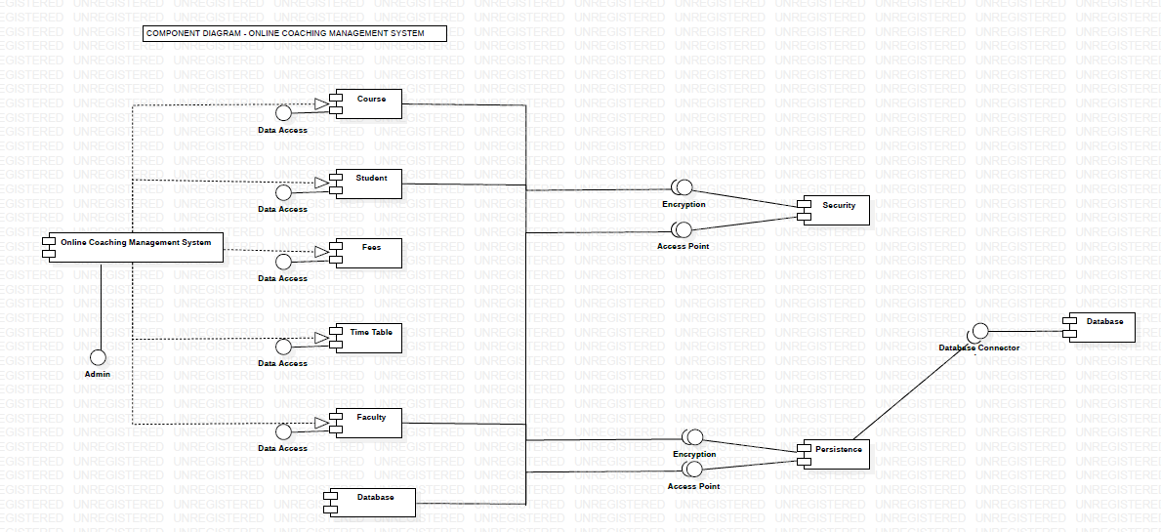

|  |  |  |  |
| --- | --- | --- | --- |
| Internal Assessment (Mandatory Experiment) Sheet for Lab Experiment Department of Computer Science & Engineering  Amity University, Noida (UP) | | | |
| Program | B. Tech CSE | Course Name | Software Engineering |
| Course Code | IT301 | Semester | 6 |
| Student Name | KRISHNA SAHU | Enrollment No. | A2305219080 |
| Marking Criteria | | | |
| Criteria | Total Marks | Marks Obtained | Comments |
| Concept (A) | 2 |  |  |
| Implementation (B) | 2 |  |  |
| Performance (C) | 2 |  |  |
| Total | 6 |  |  |